Herc Systems and Tactics.

Your Herc has a variety of combat systems. Weapon, target, scanner, shield and damage status are displayed on your vehicles HUD (Heads Up Display). Though you need not understand them all to get started, mastery of these systems will give you a significant edge in combat.

Movement
(Note: All Key listings in this document are based on the standard keyboard configuration.)

Important Keys

A, NumPad 8 Turn Left
D, NumPad 2 Turn Right
W, NumPad 3 Increase Forward Velocity
X, NumPad 4 Increase Backward Velocity (slows you down if moving forward)
S, Backspace Stop
Shift-S Power down/restart
C Crouch/Stand up

Remember that Hercs weigh many tons. Though they are surprisingly agile for their size, you still can’t stop 30 plus tons of war-machine on a dime. Hercs are able to turn more quickly at low speed than at high speed. It is a good idea to keep moving. Standing still makes you much easier to hit.

Cockpit HUD targeting view

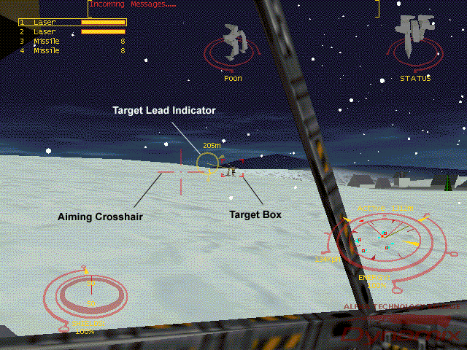
Targeting System

Important Keys:

T, NumPad Enter Target nearest enemy (non-teammate)
G, NumPad - Next enemy target (non-teammate)
Shift-G, NumPad + Previous enemy target (non-teammate)
Right Mouse Button Target object under crosshair

One of the most important systems, and one you will use most frequently, is the targeting system. First of all, you must select a target. The easiest way is usually to press the “T” or Number Pad “Enter” Key (note that this is different from the standard enter key found near the center of your keyboard). This will select the nearest enemy target on your scanner. If no enemy vehicles appear on your scanner, you will probably target a building. In addition, the target keys will not select a teammate as your current target if you are playing a team game. You must use the right mouse button to target a teammate if you are playing a team game.

Your weapons will triangulate for range on your current target. If you fire your weapons without targeting an object, your bullets are very likely to sail harmlessly past it.

The targeting system has three main components. The aiming crosshair, usually controlled by the mouse, the target box, and the target lead indicator.

When you have selected a target, a target box will appear around it, the lead indicator will be activated (unless your current weapon is a missile) and a spinning 3D model will appear in your target status display. A small box will also be drawn around the target’s icon on the scanner.

Target Lead Indicator
The target lead indicator is represented by a circle with a line connected to your current target when the target can be seen in front of you. The range to your target will appear near the top of the circle. The lead indicator is very useful, it calculates a firing solution based on range, your movement, and the target’s movement. To hit the target, you must try to line up your aiming crosshair with the center of the circle.

Weapons Systems

HUD Weapons Display
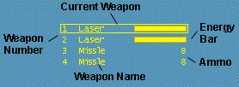

Important Keys

L Link/Unlink same weapon types
1 Select Weapon 1
2 Select Weapon 2
3 Select Weapon 3 (not available on all hercs)
4 Select Weapon 4 (not available on all hercs)
Space Bar,
Left Mouse Button,
Joystick Trigger Fire current weapon

The weapon number, name, and remaining energy or ammo are displayed on the HUD. The currently selected weapon(s) are surrounded by a box in the weapons display. Pressing “fire” will discharge the current weapon. Weapons of the same type may be linked together to fire in tandem.

Energy Weapons
Energy weapons draw power from your reserves and require 1-2 seconds to fully charge. An energy weapon may be fired at less than a full charge, but it will inflict reduced damage. Linking energy weapons will allow you to fire two at once, but will dramatically increase your energy consumption. A sustained rate of fire with linked energy weapons will quickly deplete your energy reserves and cause some Herc systems, including the HUD, to temporarily shut down.

Ballistic Weapons.
Ballistic weapons such as autocannons do not draw energy, but have limited ammunition. The target lead indicator does not account for gravity (windage) so you must manually compensate by aiming above your target at long range.

Crosshair indicating Missile Lock
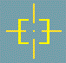

Missiles
Missiles are self-guided and do not use the target lead indicator, but they require about two seconds to lock on to a target. A box around the aiming crosshair indicates missile lock. Lock-on is not required to fire a missile volley, but the missiles will not track the target. For this reason it is usually a waste of ammo to fire several missile volleys in rapid succession.

HUD Target Status Display

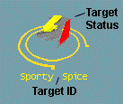
The HUD target status display indicates the Identity, vehicle or building type, and damage level of your currently selected target. Your target is represented by a 3D model: Gray areas indicate little or no damage, yellow indicates moderate damage, and red indicates heavy damage. If the HUD animations are turned on, you can tell if your target is walking, running, or crouching. If no target is selected, this display will be empty.

HUD Player Status Display

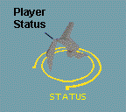
This functions identically to the Target status display, except that it always shows your vehicle.

Sensor Multi-Function Display
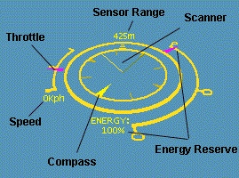

Important Keys

R Step through scanner ranges
Shift-R Toggle active/passive sensor mode
,(comma) Next Navpoint
.(period) Previous navpoint
M Set Navpoint

The sensor multi-function display integrates several components including:

Throttle
Speedometer
Compass
Energy Reserve Display
Scanner Display
Current Sensing Range and mode

Throttle and Speedometer.
The integrated throttle/speedometer at the left of the display indicates the current throttle setting as well as the actual speed of travel. If the gauge is at the top, maximum forward throttle is being applied. If the gauge is pegged at the bottom, max reverse throttle is engaged. The center tick represents no throttle. The speedometer indicates your actual current rate of travel in kilometers per hour. A positive number indicates forward velocity, and a negative indicates backwards velocity.

Compass
The innermost ring of the sensor display rotates to indicate your direction of travel. The large tick represents true north. If you have a Nav Point selected, a heading indicator will appear outside the compass ring. You can reach the nav point by following this indicator.

Energy Display.
The amount of energy reserves are displayed graphically and numerically on the right side of the display. Your reactor generates a set amount of energy each second. Weapons, shields, cloak, and the HUD systems all draw energy from the same pool. If the pool is depleted by excessive cloaking or energy weapon use, your Herc may temporarily shut down.

Sensing Range and Mode Display.
This indicates the current sensor mode and scanning range. Your Herc has two types of sensors: active and passive. Active sensors broadcast a signal and detect the reflected energy from a target. These generally provide a much greater range than passive sensors, but alert everyone in the area to your presence. Passive sensors detect targets based on energy emissions, thermal signature and motion. They are more limited in range, but are far stealthier than active sensors. The use of a cloak significantly reduces the detection range for both passive and active sensors.

Scanner
All targets visible to your current sensor mode and range will appear in the scanner. Buildings appear as blue dots, while enemy vehicles appear as blue, red, yellow, or purple dots, depending on their team. Your current target will have a box around it on the scanner display if it is within scanning range. If it is not in range, an appropriately colored tick mark will appear on the compass ring indicating the direction to your target.

Shield Display

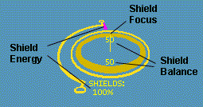
Important Keys

Enter,
NumPad * Activate/Deactivate Shield
Shift+Enter,
NumPad/ Activate/Deactivate Shield Tracking (must have enemy targeted)
Q, NumPad 7 Focus shields forward

Z, NumPad 1 Focus shields rear
[ Rotate shield focus left
] Rotate shield focus right

Shields draw energy from your Herc’s reactor to provide protection from all types of weapons. The shield display indicates the status and orientation of your Herc’s shields.

Shield Energy Display
Shield energy displays on the left side of the display indicate the amount of charge in the shields graphically and numerically. As you are hit by weapons fire, this will begin to decrease.

The Enter Key or Number Pad * (asterisk) will activate and deactivate your shields. Deactivating your shields reduces the demand on your reactor and reduces your energy signature, making it harder to detect your presence. If you severely deplete your energy reserves, shields may be automatically shut down.

Shield Balance Display.
This indicates balance of energy between the front and rear shields. In the display above, shield energy is distributed equally between front and rear. Balance is changed by pressing Q or number pad 7 to distribute energy forward and by using Z or the number pad 1 to move energy to the rear.

Shield Orientation.
A line on the shield display represents the current shield orientation. If you choose to change the shield balance, you can rotate the strongest shield to face enemy threats. Shields can be set to automatically “track” your current target by pressing the Shift and Enter keys simultaneously or by pressing the number pad / key. Shield orientation can be manually changed with the bracket keys [ and ].

Special Herc Functions

Cloaking
Hercs that are cloaked are much harder to track visually and are difficult to pick up on your scanners. E, and Number Pad 9 will toggle your Herc’s cloak.

Crouching and Powering Down
Crouching can allow your Herc to hide or avoid enemy fire in some situations. If you power down your herc by pressing Shift-S you will automatically crouch. To crouch without powering down, use C, or the Number Pad 3 to toggle a crouch.

Projectile Camera
Pressing O will cause your camera view to follow the next projectile you fire.

Message Window

Important Keys

F4 Toggles window modes (small, large, shadowed).

This window displays chat messages from other players and obituary announcements from the game server.

Player Chat Window

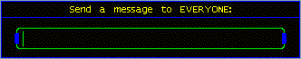
Important Keys

F5 - send message to EVERYONE (shout)
F6 - send message to your TEAM
F7 - send message to your current TARGET
F8 - send message to a specific PLAYER

Pressing a function key F5-F8 will bring up a chat dialog box and allow you to send a message to other players in the game. Type your text in the box and press “Enter” to send it.

HUD Preferences Menu

The HUD instruments in your cockpit can be customized to suit your personal tastes. Players running in lower screen resolutions may wish to disable some HUD functions to reduce the clutter on the screen.

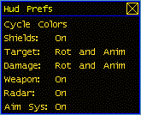

Important Keys

F2 Activate/Deactivate HUD preferences menu
Left Mouse Button Toggle menu choices, click and drag to reposition HUD instruments

When the HUD preferences menu is activated a border will appear around each HUD instrument. You can reposition the instruments on the HUD wherever you like by left-clicking on them and dragging to a new location. Instrument display may be toggled by left-clicking on the appropriate item in the HUD Prefs.

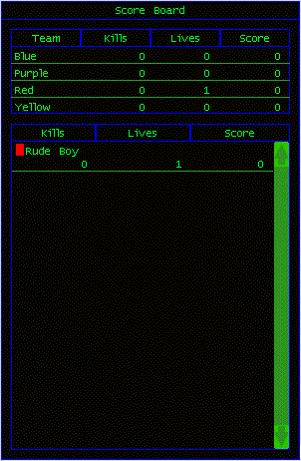
Player Scoreboard

Important Keys

F3 Toggles Score Board (in simulation only)

The scoreboard tracks the score and number of kills made by player and by team in the multi-player session. A color box next to the name of each player indicates his or her team.

Repairing and Re-Arming your Herc
If you are damaged in battle, you can make field repairs to your Herc if you are able to find a repair pad. If you run out of ammunition, you can use a rearming pad. Simply drive your Herc onto the pad, and shut down (Shift-S will power down or start up your herc).

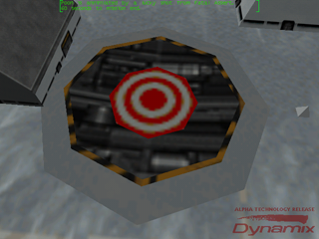
Repair Pad Rearming Pad
